Stage 2 - Toxic
COURSE DESIGNER: Ike Starnes

SCORING: Comstock 12 rounds.
TARGETS: 6 cardboard targets
SCORED HITS: 2 Best hits per carboard will be scored.
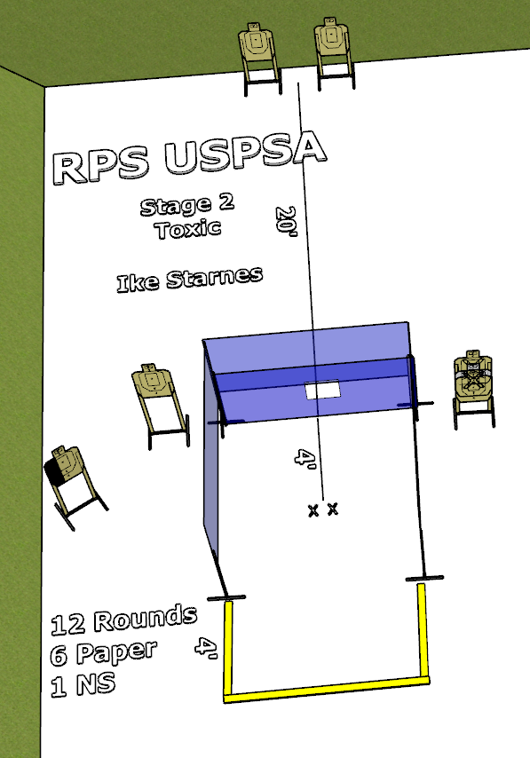

Written Stage Briefing:

Stage 2 - Toxic - is a 12 round, 60 point, Comstock course. There are 6 cardboard targets. The best 2 hits per cardboard target will be scored.
Start position Both feet touching the Shooting Sports Innovations Xs, facing generally downrange.
Handgun: Loaded and holstered, hands on head.
PCC: Loaded, stock touching belt, strong hand on head.

Targets USA Bigfoot stomp pad activates the bobber, which remains visible at rest.

On the audible start signal, engage targets from within the shooting area.

USPSA / NROI Range Commands:
- Make Ready
- Are you ready?
- Standby
- If finished, unload and show clear.
- If clear, hammer down and holster
- Range is clear

Setup Notes:
18 Single Wall Stands
4 Full Walls
2 Port Walls
2 Half Walls
15 Target stands / 30 target sticks
1 Bobbers + activation hardware and target sticks
1 Swinger + activation hardware and target sticks
1 Targets USA Bigfoot Stomp Pad
22+ barrels

